NEXTAG COMPANY

Saffiano Cuir leather wallet

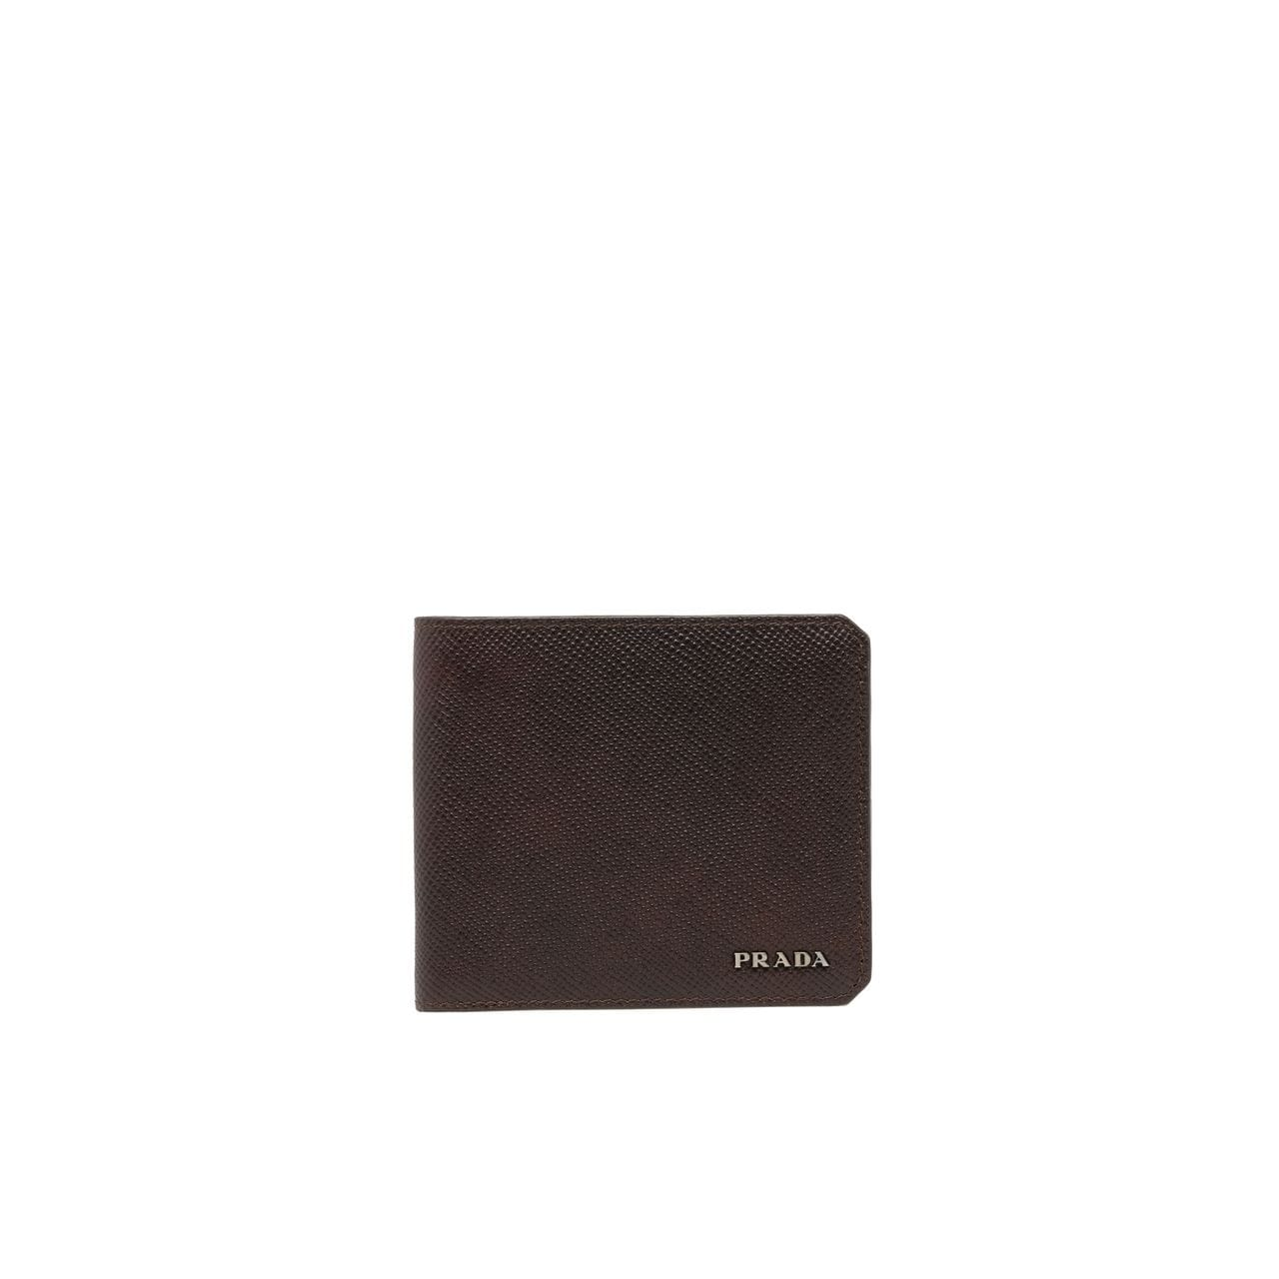

Style # 1MV204_2CDM_F0YQY

440 $

product details

Saffiano Cuir leather-–Two bill compartments  
Eight credit card slots  
Two document pockets  
Leather lining  
Metal lettering logo  
9.5 cm height  
11 cm width